**APPENDIX I**

PROJECT REPORT

Submitted by

Devansh Dubey

[Reg No12417428]

In partial fulfillment for the award of degree

Of

Bachelor of Technology IN

Computer Science and Engineering



Lovely Professional University, Punjab November 2024

Table of Contents

|  |  |  |
| --- | --- | --- |
| Sr. No. | Content | Page No. |
| 1 | Title Page | 1 |
| 2 | Table of Contents | 2 |
| 3 | Introduction | 3-4 |
| 4 | Technology used | 5 |
| 5 | Workflow | 6 |
| 6 | Working of Project | 7-22 |
| 7 | Code Snippets | 23-25 |
| 8 | Screenshots | 26 |
| 9 | Conclusion | 27 |
| 10 | Reference | 28 |
|  |  |  |

**Introduction**

**Welcome to Quick Shopping**

Quick commerce is a model that allows customers to receive their orders within an hour of placing them. It's usually used for small orders, rather than large grocery orders..

*Key Features of Quick Shopping:*

1 [3:03 PM, 11/14/2024] Atul Raj Singh: E-commerce websites

These digital storefronts allow businesses to sell products and services online. Customers can browse products, read reviews, compare prices, and make purchases.

E-commerce benefits

E-commerce can help businesses reach a wider customer base, and can also be cheaper than running a physical store.

E-commerce security

It's important to protect confidential information like credit card and bank account numbers. Digital signatures can help make this easier and safer.

E-commerce content regulation

Some online content is considered inappropriate or harmful, and there are concerns about the need for regulation. However, there are also counterarguments about the right to free speech and expression.

[3:04 PM, 11/14/2024] Atul Raj Singh: Fast delivery: Quick commerce offers fast delivery speeds and doorstep delivery.

Easy order tracking: Customers can easily monitor and track their orders.

Simple UI: Quick commerce platforms have a simple user interface.

Curated selection: Quick commerce offers a curated selection of products.

Order planning: Customers can reserve a time and day for their order delivery.

Delivery scheduler: Customers can schedule their delivery in advance.

Payment gateway: Customers can pay on the spot and get an instant receipt.

Membership: Some on-demand applications offer membership benefits such as free delivery

\**Benefits of Creating a Quick Shopping:\**

[3:05 PM, 11/14/2024] Atul Raj Singh: Lower Costs. Cost reduction is one of the key benefits of ecommerce websites that keep sellers engaged in online selling.

[3:06 PM, 11/14/2024] Atul Raj Singh: Customer Data Insight. Another benefit of selling products online is the ease of collecting, measuring, and acting upon data.

# TECHNOLOGIES USED

Creating an engaging and functional websites like Quick Shopping

involves utilizing technologies like HTML and CSS

In this case, I have used HTML and concepts of CSS ( for designing ) for building the quick shopping website.

HTML (Hyper-Text Markup Language):

* HTML is the standard markup language for creating Web pages
* HTML describes the structure of a Web page
* HTML consists of a series of elements
* HTML elements tell the browser how to display the content
* HTML elements label pieces of content such as "this is a heading", "this is a paragraph", "this is a link", etc.

CSS (Cascading Style Sheet):

* CSS describes how HTML elements are to be displayed on screen, paper, or in other media
* CSS saves a lot of work. It can control the layout of multiple web pages all at once
* External stylesheets are stored in CSS files
* It helps in designing the website by using properties like color, background-color etc.
* It is also used for giving animation effects, hover effects and many more.
* By using media queries, one is able to create responsive website which is done using CSS.

### WORKFLOW

> Start

> Project Planning

> HTML

> CSS

> Adding Images

> Adding Various other features

> Completing Frontend of the Website

> End.

## Working of Quick Shopping

## Homepage:

When users visit the site, they land on homepage, which showcase about coe’s, cuisines and many more.

Users can easily navigate through dif.

1. Clickable Features:

Whenever user click on the sun icon, the background color of the website changes to black.

And when the user clicks again it turns to grey background.

1. Hover Effects:

Whenever user moves the cursor over the navbar items, the border around the items appears in white color.

1. Responsive Design:

The website is designed to work well on both the desktops and mobile devices. This means users can browse comfortably, regardless of the device they are using.

1. Visual Appeal:

The website uses attractive colors, fonts, and layouts to make the browsing experience enjoyable and engaging for users.

Overall, the Food Eatate website make it easy to explore Eatate options, order online, and learn more about the brand’s philosophy and community involvement.

## Code Snippets

### HTML:

<!DOCTYPE html>

<html lang="en">

<head>

    <meta charset="UTF-8">

    <meta name="viewport" content="width=device-width, initial-scale=1.0">

    <title>Quick Shopping</title>

    <link rel="stylesheet" href="styles.css">

</head>

<body>

    <section id="y">

    <header>

        <h1>Quick Shopping</h1>

        <nav>

            <ul>

                <li><a href="index.html">Home</a></li>

                <li><a href="mark.html">Items</a></li>

                <li><a href="buy.html">BUY NOW</a></li>

                <li><a href="#contact">Contact</a></li>

                <li><a href="#about">About Us</a></li>

            </ul>

        </nav>

    </header>

    <section id="a"><img src="web1.webp" alt=""></section>

    <div class="a"><b>Products</b></div>

    <a href="mark.html"><section id="b"><img  src="keys.webp" alt=""><b>Keyboard</b>

    </section></a>

    <a href="mark.html"><section id="c"><img src="mouse1.webp" alt=""><b >Mouse</b>

    </section></a>

    <a href="mark.html"><section id="d"><img src="monitors.jpg" alt=""><b >Monitors</b>

    </section></a>

    <a href="mark.html"><section id="e"><img src="printer.webp" alt=""><b >printer</b>

    </section></a>

    <a href="mark.html"><section id="f"><img src="shopping.webp" alt=""><b >Processor</b>

    </section></a>

    <a href="mark.html"><section id="g"><img src="webcam1.webp" alt=""><b >Webcam</b>

    </section></a>

    <a href="mark.html"><section id="h"><img src="gamepad1.webp" alt=""><b >Gamepad</b>

    </section></a>

    <a href="mark.html"><section id="i"><img src="router1.webp" alt=""><b >Router</b>

    </section></a>

    <a href="mark.html"><section id="j"><img src="speakers.webp" alt=""><b>Speakers</b>

    </section></a>

    <a href="mark.html"><section id="k"><img src="mousepad1.webp" alt=""><b>Mouse Pad</b>

    </section></a>

    <a href="mark.html"><section id="l"><img src="headphone1.webp" alt=""><b>Headphones</b>

    </section></a>

    <a href="mark.html"><section id="m"><img src="giga1.webp" alt=""><b>Graphics Card</b>

    </section></a>

    <a href="mark.html"><section id="n"><img src="ports.jpg" alt=""><b>Ports</b>

    </section></a>

    <a href="mark.html"><section id="o"><img src="micro.webp" alt=""><b>Microphones</b>

    </section></a>

    <a href="mark.html"><section id="p"><img src="cool.jpg" alt=""><b>Cooling Pad</b>

    </section></a>

    <section id="contact">

        <h2>Contact Us</h2>

        <p>If you have any questions, feel free to reach out!</p>

        <p>Email: info@quickshopping.org</p>

        <p>Phone: (123) 456-7890</p>

    </section>

     <footer>

        <p>&copy; 2023 Quick Shopping. All rights reserved.</p>

    </footer> </section>

</body>

</html>

2nd page

<!DOCTYPE html>

<html lang="en">

<head>

    <meta charset="UTF-8">

    <meta name="viewport" content="width=device-width, initial-scale=1.0">

    <title>Quick Shopping</title>

    <link rel="stylesheet" href="styles.css">

</head>

<body>

    <section id="z">

    <header>

        <h1>Quick Shopping</h1>

        <nav>

            <ul>

                <li><a href="index.html">Home</a></li>

                <li><a href="mark.html">Items</a></li>

                <li><a href="buy.html">BUY NOW</a></li>

                <li><a href="#contact">Contact</a></li>

                <li><a href="#about">About Us</a></li>

            </ul>

        </nav>

    </header>

    <section id="asdf" ><b>Products</b></section>

    <section id="aa"><img class="b" src="mouse11.jpg" alt=""><b>Asus WT300 Ergonomic Wireless Mouse <br><a href="buy.html">Buy NOW</a><br>8.96$</b></section>

    <section id="bb"><img class="b" src="mouse2.webp" alt=""><b>Asus MW203 Multi-Device Wireless Silent Mouse <br><a href="buy.html">Buy NOW</a><br>18.96$</b></section>

    <section id="cc"><img class="b" src="mouse3.webp" alt=""><b>ASUS Marshmallow Mouse MD100 Steven Harrington Edition/Silent <br><a href="buy.html">Buy NOW</a><br>24.49$</b></section>

    <section id="dd"><img class="b" src="mouse4.png" alt=""><b>Asus MD100 Marshmallow/Silent DP <br><a href="buy.html">Buy NOW</a><br>26.99$</b></section>

    <section id="ee"><img class="c" src="keyboard1.webp" alt=""><b>ASUS Marshmallow Mouse MD100 Steven Harrington Edition/Silent <br><a href="buy.html">Buy NOW</a><br>24.49$</b></section>

    <section id="ff"><img class="c" src="keyboard2.webp" alt=""><b>Asus WT300 Ergonomic Wireless Mouse <br><a href="buy.html">Buy NOW</a><br>8.96$</b></section>

    <section id="gg"><img class="c" src="keyboard3.webp" alt=""><b>Asus MD100 Marshmallow/Silent DP <br><a href="buy.html">Buy NOW</a><br>26.99$</b></section>

    <section id="hh"><img class="c" src="keyboard4.webp" alt=""><b>Asus MW203 Multi-Device Wireless Silent Mouse <br><a href="buy.html">Buy NOW</a><br>18.96$</b></section>

    <section id="ii"><img class="d" src="monitors1.webp" alt=""><b>Samsung 27-inch(67.8cm) Odyssey OLED G6 Gaming, 360Hz, 0.03 <br><a href="buy.html">Buy NOW</a><br>107.99$</b></section>

    <section id="jj"><img class="d" src="monitors2.webp" alt=""><b>Acer UM.SE1AA.S02 Nitro EI491CR S Widescreen Gaming LCD <br><a href="buy.html">Buy NOW</a><br>607$ </b></section>

    <section id="kk"><img class="d" src="monitors3.webp" alt=""><b>TITAN ARMY 49 inch curved 144Hz Type-C65W HDR 32:9 dual display <br><a href="buy.html">Buy NOW</a><br>1447$</b></section>

    <section id="ll"><img class="d" src="monitors4.webp" alt=""><b>Samsung ODYSSEY G5 (LC34G55TWWWXXL) 34" Curved Gaming <br><a href="buy.html">Buy NOW</a><br>535.87$</b></section>

    <section id="mm"><img class="e" src="processor1.webp" alt=""><b>AMD Ryzen 5 7600X 6 Cores 12 Threads Desktop Processor <br><a href="buy.html">Buy NOW</a><br>107.47$</b></section>

    <section id="nn"><img class="e" src="processor2.webp" alt=""><b>AMD Ryzen 3 3200G Processor With Radeon Vega 8 Graphics <br><a href="buy.html">Buy NOW</a><br>87.49$</b></section>

    <section id="oo"><img class="e" src="processor3.webp" alt=""><b>AMD Ryzen 7 8700F Processor (100-100001590BOX) <br><a href="buy.html">Buy NOW</a><br>107.99$</b></section>

    <section id="pp"><img class="e" src="processor4.webp" alt=""><b>AMD Ryzen 5 7600X 6 Cores 12 Threads Desktop Processor <br><a href="buy.html">Buy NOW </a><br>73.95$</b></section>

    <section id="qq"><img class="f" src="graphics1.webp" alt=""><b>Gigabyte GeForce RTX 4070 Ti SUPER WINDFORCE  <br><a href="buy.html">Buy NOW</a><br>1000.99$</b></section>

    <section id="rr"><img class="f" src="graphics2.webp" alt=""><b>NVIDIA GeForce RTX 3070 FOUNDER EDITION 8GB GDDR6 Graph <br><a href="buy.html">Buy NOW</a><br>305.76$</b></section>

    <section id="ss"><img class="f" src="graphics3.webp" alt=""><b>Asus Rog Matrix Rtx 4090 Platinum 24Gb Graphics Card (ROG-MATRIX-RTX4090-P24G-GAMING) <br><a href="buy.html">Buy NOW</a><br>4821.42$</b></section>

    <section id="tt"><img class="f" src="graphics4.webp" alt=""><b>Premium Asus Geforce Gt710 (Graphic Card)ASUS · Graphics Card <br><a href="buy.html">Buy NOW</a><br>1800.75$</b></section>

    <section id="uu"><img class="g" src="speakers1.webp" alt=""><b>ZEBRONICS Zeb-Warrior II 10 W 2.0 Multimedia Speaker with RGB <br><a href="buy.html">Buy NOW</a><br>15.99$</b></section>

    <section id="vv"><img class="g" src="speakers2.webp" alt=""><b>Philips Audio SPA8000B/94 5.1 Channel 120W Multimedia Speaker <br><a href="buy.html">Buy NOW</a><br>75$</b></section>

    <section id="ww"><img class="g" src="speakers3.webp" alt=""><b>Blackstar HighLIGHT10 Bluetooth Speaker - with Disco LED Lights <br><a href="buy.html">Buy NOW</a><br>43.65$</b></section>

    <section id="xx"><img class="g" src="speakers4.webp" alt=""><b>Sony SA-D40 4.1 Channel Multimedia Speaker System with Bluetooth <br><a href="buy.html">Buy NOW</a><br>84.99$</b></section>

    <!-- <section class="h" id="yy"><b></b></section>

    <section class="h" id="zz"><b></b></section> -->

 <section id="contact">

        <h2>Contact Us</h2>

        <p>If you have any questions, feel free to reach out!</p>

        <p>Email: info@quickshopping.org</p>

        <p>Phone: (123) 456-7890</p>

    </section>

     <footer>

        <p>&copy; 2023 Quick shopping. All rights reserved.</p>

    </footer> </section>

</body>

</html>

3rd page

<!DOCTYPE html>

<html lang="en">

<head>

    <meta charset="UTF-8">

    <meta name="viewport" content="width=device-width, initial-scale=1.0">

    <title>Quick Shopping</title>

    <link rel="stylesheet" href="styles.css">

</head>

<body>

    <section id="z">

    <header>

        <h1>Quick Shopping</h1>

        <nav>

            <ul>

                <li><a href="index.html">Home</a></li>

                <li><a href="mark.html">Items</a></li>

                <li><a href="buy.html">BUY NOW</a></li>

                <li><a href="#contact">Contact</a></li>

                <li><a href="#about">About Us</a></li>

            </ul>

        </nav>

    </header>

    <form action="">

        <section id="pos">Name</section>

        <input type="text" name="name">

    <section id="pos">Shipping Address</section>

    <input type="text">

    <section id="pos">Payment Method</section>

    <section id="not">Online Payment</section>

    <section id="not">Cash on delivery </section>

    <section id="pos"><b>BUY NOW</b></section>

    </form>

      <section id="contact">

        <h2>Contact Us</h2>

        <p>If you have any questions, feel free to reach out!</p>

        <p>Email: info@quickshopping.org</p>

        <p>Phone: (123) 456-7890</p>

    </section>

     <footer>

        <p>&copy; 2023 Quick shopping. All rights reserved.</p>

    </footer> </section>

</body>

</html>

### CSS:

body {

    font-family: Arial, sans-serif;

    line-height: 1.6;

    margin: 0;

    padding: 0;

    box-sizing: border-box 10px;

    border: #252725;

}

header {

    background-image: url(grey1.jpg);

    color: white;

    padding: 10px 0;

    text-align: center;

    border-radius: 15px;

}

nav ul {

    list-style: none;

    padding: 0;

}

nav ul li {

    display: inline;

    margin: 0 15px;

}

nav ul li a {

    color: white;

    text-decoration: none;

}

section {

    padding: 20px;

    margin: 20px;

    border: 1px solid #ddd;

    border-radius: 5px;

}

h2 {

    color: #4CAF50;

}

form {

    display: flex;

    flex-direction: column;

}

form label {

    margin: 10px 0 5px;

}

form input {

    padding: 10px;

    margin-bottom: 10px;

    border: 1px solid #ddd;

    border-radius: 5px;

}

form button {

    padding: 10px;

    background: #4CAF50;

    color: white;

    border: none;

    border-radius: 5px;

    cursor: pointer;

}

form button:hover {

    background: #45a049;

}

 footer {

    text-align: center;

    padding: 10px 0;

    background: #f1f1f1;

    position: absolute;

    top: 3800px;

    margin-left: 600px;

}

img {

   width: 100%;

   border-radius: 15px;

}

#a{ border-radius: 15px;

    border: 5px solid;

    border-color:rgb(20, 23, 122);

}

 #b{

    margin-left: 50px;

    width: 20%;

    position: absolute;

    background-image: url(blue.jpg);

    height: 350px;

    text-align: center;

    color: rgb(245, 245, 246);

    font-family:Verdana, Geneva, Tahoma, sans-serif;

    font-size: 25px;

    border-radius: 15px;

}

#c{

    width: 20%;

    position: absolute;

    margin-left: 550px;

    background-image: url(blue.jpg);

    text-align: center;

    color: rgb(245, 245, 246);

    font-family:Verdana, Geneva, Tahoma, sans-serif;

    font-size: 25px;

    border-radius: 15px;

}

#d{

    width: 20%;

    position: absolute;

    margin-left: 1050px;

    background-image: url(blue.jpg);

    text-align: center;

    color: rgb(245, 245, 246);

    font-family:Verdana, Geneva, Tahoma, sans-serif;

    font-size: 25px;

    border-radius: 15px;

}

#e{

    margin-left: 50px;

    width: 20%;

    position: absolute;

    top: 1500px;

    background-image: url(blue.jpg);

    text-align: center;

    color: rgb(245, 245, 246);

    font-family:Verdana, Geneva, Tahoma, sans-serif;

    font-size: 25px;

    border-radius: 15px;

}

#f{

    width: 20%;

    position: absolute;

    top: 1500px;

    margin-left: 550px;

    background-image: url(blue.jpg);

    text-align: center;

    color: rgb(245, 245, 246);

    font-family:Verdana, Geneva, Tahoma, sans-serif;

    font-size: 25px;

    border-radius: 15px;

}

#g{

    width: 20%;

    position: absolute;

    top: 1500px;

    margin-left: 1050px;

    background-image: url(blue.jpg);

    text-align: center;

    color: rgb(245, 245, 246);

    font-family:Verdana, Geneva, Tahoma, sans-serif;

    font-size: 25px;

    border-radius: 15px;

}

#h{

    margin-left: 50px;

    width: 20%;

    position: absolute;

    top: 2000px;

    background-image: url(blue.jpg);

    text-align: center;

    color: rgb(245, 245, 246);

    font-family:Verdana, Geneva, Tahoma, sans-serif;

    font-size: 25px;

    border-radius: 15px;

}

#i{

    width: 20%;

    position: absolute;

    top: 2000px;

    margin-left: 550px;

    background-image: url(blue.jpg);

    text-align: center;

    color: rgb(245, 245, 246);

    font-family:Verdana, Geneva, Tahoma, sans-serif;

    font-size: 25px;

    border-radius: 15px;

}

#j{

    width: 20%;

    position: absolute;

    top: 2000px;

    margin-left: 1050px;

    background-image: url(blue.jpg);

    text-align: center;

    color: rgb(245, 245, 246);

    font-family:Verdana, Geneva, Tahoma, sans-serif;

    font-size: 25px;

    border-radius: 15px;

}

#k{

    margin-left: 50px;

    width: 20%;

    position: absolute;

    top: 2500px;

    background-image: url(blue.jpg);

    text-align: center;

    color: rgb(245, 245, 246);

    font-family:Verdana, Geneva, Tahoma, sans-serif;

    font-size: 25px;

    border-radius: 15px;

}

#l{

    width: 20%;

    position: absolute;

    top: 2500px;

    margin-left: 550px;

    background-image: url(blue.jpg);

    text-align: center;

    color: rgb(245, 245, 246);

    font-family:Verdana, Geneva, Tahoma, sans-serif;

    font-size: 25px;

    border-radius: 15px;

}

#m{

    width: 20%;

    position: absolute;

    top: 2500px;

    margin-left: 1050px;

    background-image: url(blue.jpg);

    height: 340px;

    text-align: center;

    color: rgb(245, 245, 246);

    font-family:Verdana, Geneva, Tahoma, sans-serif;

    font-size: 25px;

    border-radius: 15px;

}

#n{

    margin-left: 50px;

    width: 20%;

    position: absolute;

    top: 3000px;

    background-image: url(blue.jpg);

    text-align: center;

    color: rgb(245, 245, 246);

    font-family:Verdana, Geneva, Tahoma, sans-serif;

    font-size: 25px;

    border-radius: 15px;

}

#o{

    width: 20%;

    position: absolute;

    top: 3000px;

    margin-left: 550px;

    background-image: url(blue.jpg);  text-align: center;

    color: rgb(245, 245, 246);

    font-family:Verdana, Geneva, Tahoma, sans-serif;

    font-size: 25px;

    border-radius: 15px;

}

#p{

    width: 20%;

    position: absolute;

    top: 3000px;

    margin-left: 1050px;

    background-image: url(blue.jpg);

    text-align: center;

    color: rgb(245, 245, 246);

    font-family:Verdana, Geneva, Tahoma, sans-serif;

    font-size: 25px;

    border-radius: 15px;

}

#y{

     border-color:rgb(20, 23, 122);

    border-radius: 15px;

    height: 3500px;

    width: 95%;

    border: 5px solid;

}

#z{

    border-color:rgb(20, 23, 122);

   border-radius: 15px;

   height: 3800px;

   width: 95%;

   border: 5px solid;

}

.a{width: 20%;

    border: 1px solid navy;

    text-align: center;

    font-size: 20px;

}

/* .b{

    margin-left: 50px;

    width: 20%;

    position: absolute;

    background-image: url(blue.jpg);

    height: 350px;

    text-align: center;

    color: rgb(245, 245, 246);

    font-family:Verdana, Geneva, Tahoma, sans-serif;

    font-size: 25px;

    border-radius: 15px;

} */

 .b{

    height: 400px;

 }

#aa{

    width: 20%;

    position: absolute;

    margin-left: 5px;

    background-image: url(blue.jpg);

    text-align: center;

    color: rgb(245, 245, 246);

    font-family:Verdana, Geneva, Tahoma, sans-serif;

    font-size: 15px;

    border-radius: 15px;

    height: 500px;

}

#bb{

    width: 20%;

    position: absolute;

    margin-left: 360px;

    background-image: url(blue.jpg);

    text-align: center;

    color: rgb(245, 245, 246);

    font-family:Verdana, Geneva, Tahoma, sans-serif;

    font-size: 15px;

    border-radius: 15px;

    height: 500px;

}

#cc{

    margin-left: 730px;

    width: 20%;

    position: absolute;

    background-image: url(blue.jpg);

    text-align: center;

    color: rgb(245, 245, 246);

    font-family:Verdana, Geneva, Tahoma, sans-serif;

    font-size: 15px;

    border-radius: 15px;

    height: 500px;

}

#dd{

    margin-left: 1100px;

    width: 20%;

    position: absolute;

    background-image: url(blue.jpg);

    text-align: center;

    color: rgb(245, 245, 246);

    font-family:Verdana, Geneva, Tahoma, sans-serif;

    font-size: 15px;

    border-radius: 15px;

    height: 500px;

}

#ee{

    width: 20%;

    position: absolute;

    top: 850px;

    margin-left: 5px ;

    background-image:url(blue.jpg) ;

    text-align: center;

    color: rgb(245, 245, 246);

    font-family:Verdana, Geneva, Tahoma, sans-serif;

    font-size: 15px;

    border-radius: 15px;

    height: 400px;

}

#ff{

    width: 20%;

    position: absolute;

    top: 850px;

    margin-left: 360px;

    background-image: url(blue.jpg);

    text-align: center;

    color: rgb(245, 245, 246);

    font-family:Verdana, Geneva, Tahoma, sans-serif;

    font-size: 15px;

    border-radius: 15px;

    height: 400px;

}

#gg{

    width: 20%;

    position: absolute;

    top: 850px;

    margin-left: 730px;

    background-image: url(blue.jpg);

    text-align: center;

    color: rgb(245, 245, 246);

    font-family:Verdana, Geneva, Tahoma, sans-serif;

    font-size: 15px;

    border-radius: 15px;

    height: 400px;

}

#hh{

    width: 20%;

    position: absolute;

    top:850px;

    margin-left:1100px;

    background-image: url(blue.jpg);

    text-align: center;

    color: rgb(245, 245, 246);

    font-family:Verdana, Geneva, Tahoma, sans-serif;

    font-size: 15px;

    border-radius: 15px;

    height: 400px;

}

#ii{

    width: 20%;

    position: absolute;

    top: 1330px;

    margin-left: 5px;

    background-image:url(blue.jpg);

    text-align: center;

    color: rgb(245, 245, 246);

    font-family:Verdana, Geneva, Tahoma, sans-serif;

    font-size: 15px;

    border-radius: 15px;

    height: 500px;

}

#jj{

    width: 20%;

    position: absolute;

    top: 1330px;

    margin-left:360px;

    background-image: url(blue.jpg);

    text-align: center;

    color: rgb(245, 245, 246);

    font-family:Verdana, Geneva, Tahoma, sans-serif;

    font-size: 15px;

    border-radius: 15px;

    height: 500px;

}

#kk{

    width: 20%;

    position: absolute;

    top: 1330px;

    margin-left:730px;

    background-image: url(blue.jpg);

    text-align: center;

    color: rgb(245, 245, 246);

    font-family:Verdana, Geneva, Tahoma, sans-serif;

    font-size: 15px;

    border-radius: 15px;

    height: 500px;

}

#ll{

    width: 20%;

    position: absolute;

    top: 1330px;

    margin-left:1100px;

    background-image:url(blue.jpg);

    text-align: center;

    color: rgb(245, 245, 246);

    font-family:Verdana, Geneva, Tahoma, sans-serif;

    font-size: 15px;

    border-radius: 15px;

    height: 500px;

}

#mm{

    width: 20%;

    position: absolute;

    top: 1910px;

    margin-left:5px;

    background-image:url(blue.jpg);

    text-align: center;

    color: rgb(245, 245, 246);

    font-family:Verdana, Geneva, Tahoma, sans-serif;

    font-size: 15px;

    border-radius: 15px;

    height: 500px;

}

#nn{

    width: 20%;

    position: absolute;

    top: 1910px;

    margin-left:360px;

    background-image: url(blue.jpg);

    text-align: center;

    color: rgb(245, 245, 246);

    font-family:Verdana, Geneva, Tahoma, sans-serif;

    font-size: 15px;

    border-radius: 15px;

    height: 500px;

}

#oo{

    width: 20%;

    position: absolute;

    top: 1910px;

    margin-left:730px;

    background-image: url(blue.jpg);

    text-align: center;

    color: rgb(245, 245, 246);

    font-family:Verdana, Geneva, Tahoma, sans-serif;

    font-size: 15px;

    border-radius: 15px;

    height: 500px;

}

#pp{

    width: 20%;

    position: absolute;

    top: 1910px;

    margin-left:1100px;

    background-image: url(blue.jpg);

    text-align: center;

    color: rgb(245, 245, 246);

    font-family:Verdana, Geneva, Tahoma, sans-serif;

    font-size: 15px;

    border-radius: 15px;

    height: 500px;

}

.c{

    height: 300px;

}

.d{

    height: 400px;

}

.e{

    height: 400px;

}

.f{

    height: 400px;

}

.g{

    height: 400px;

}

#qq{

    width: 20%;

    position: absolute;

    top: 2490px;

    margin-left: 5px;

    background-image: url(blue.jpg);

    text-align: center;

    color: rgb(245, 245, 246);

    font-family:Verdana, Geneva, Tahoma, sans-serif;

    font-size: 15px;

    border-radius: 15px;

    height: 500px;

}

#rr{

    width: 20%;

    position: absolute;

    top: 2490px;

    margin-left: 360px;

    background-image: url(blue.jpg);

    text-align: center;

    color: rgb(245, 245, 246);

    font-family:Verdana, Geneva, Tahoma, sans-serif;

    font-size: 15px;

    border-radius: 15px;

    height: 500px;

}

#ss{

    width: 20%;

    position: absolute;

    top: 2490px;

    margin-left: 730px;

    background-image: url(blue.jpg);

    text-align: center;

    color: rgb(245, 245, 246);

    font-family:Verdana, Geneva, Tahoma, sans-serif;

    font-size: 15px;

    border-radius: 15px;

    height: 500px;

}

#tt{

    width: 20%;

    position: absolute;

    top: 2490px;

    margin-left: 1100px;

    background-image: url(blue.jpg);

    text-align: center;

    color: rgb(245, 245, 246);

    font-family:Verdana, Geneva, Tahoma, sans-serif;

    font-size: 15px;

    border-radius: 15px;

    height: 500px;

}

#uu{

    width: 20%;

    position: absolute;

    top: 3070px;

    margin-left: 5px;

    background-image: url(blue.jpg);

    text-align: center;

    color: rgb(245, 245, 246);

    font-family:Verdana, Geneva, Tahoma, sans-serif;

    font-size: 15px;

    border-radius: 15px;

    height: 500px;

}

#vv{

    width: 20%;

    position: absolute;

    top: 3070px;

    margin-left: 360px;

    background-image: url(blue.jpg);

    text-align: center;

    color: rgb(245, 245, 246);

    font-family:Verdana, Geneva, Tahoma, sans-serif;

    font-size: 15px;

    border-radius: 15px;

    height: 500px;

}

#ww{

    width: 20%;

    position: absolute;

    top: 3070px;

    margin-left: 730px;

    background-image: url(blue.jpg);

    text-align: center;

    color: rgb(245, 245, 246);

    font-family:Verdana, Geneva, Tahoma, sans-serif;

    font-size: 15px;

    border-radius: 15px;

    height: 500px;

}

#xx{

    width: 20%;

    position: absolute;

    top: 3070px;

    margin-left: 1100px;

    background-image:url(blue.jpg);

    text-align: center;

    color: rgb(245, 245, 246);

    font-family:Verdana, Geneva, Tahoma, sans-serif;

    font-size: 15px;

    border-radius: 15px;

    height: 500px;

}

#yy{

    width: 20%;

    position: absolute;

    top: 3350px;

    margin-left: 5px;

    background-image: url(blue.jpg);

    text-align: center;

    color: rgb(245, 245, 246);

    font-family:Verdana, Geneva, Tahoma, sans-serif;

    font-size: 25px;

    border-radius: 15px;

    height: 500px;

}

#asdf{

    width: 20%;

    background-image: url(grey1.jpg);

    color: aliceblue;

}

#pos{

    width: 10%;

}

#not{

    width: 20%;

}

#contact{

    position: absolute;

    top: 3610px;

}

/*

#zz{

    width: 20%;

    position: absolute;

    top: 2750px;

    margin-left: 360px;

    background-image:

    text-align: center;

    color: rgb(245, 245, 246);

    font-family:Verdana, Geneva, Tahoma, sans-serif;

    font-size: 25px;

    border-radius: 15px;

}

 */

Screenshots

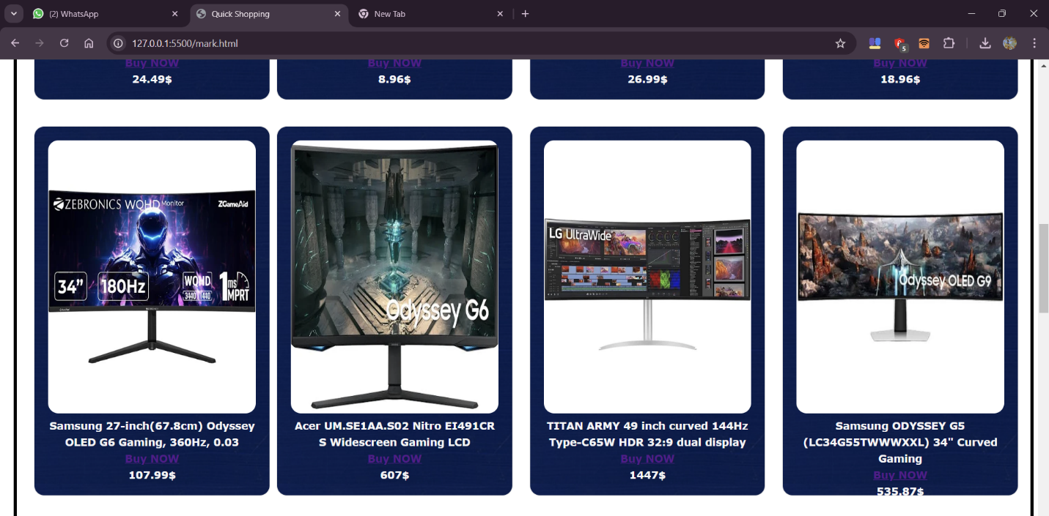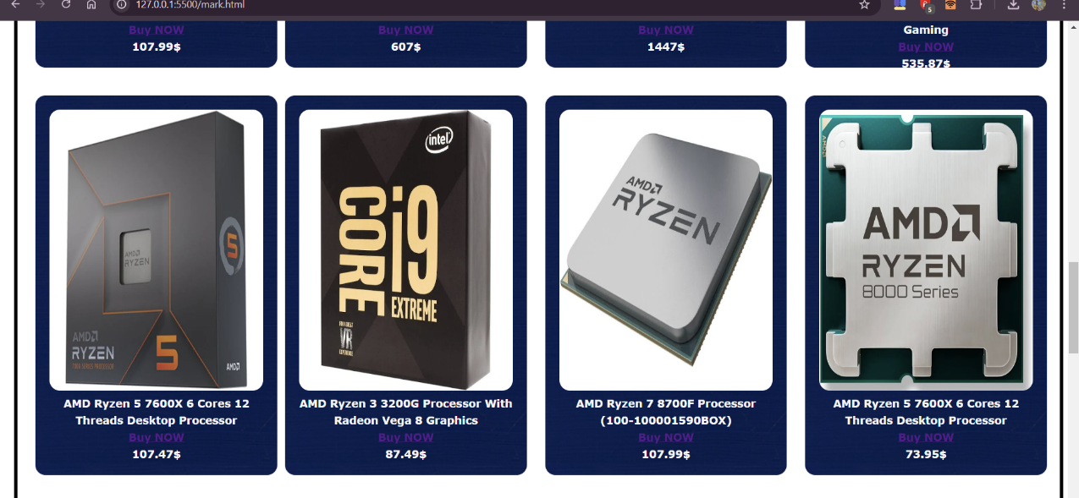

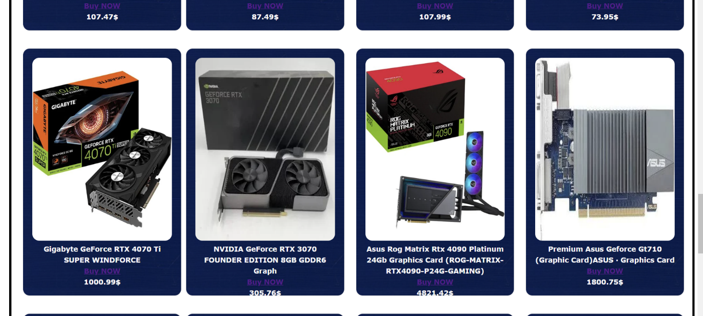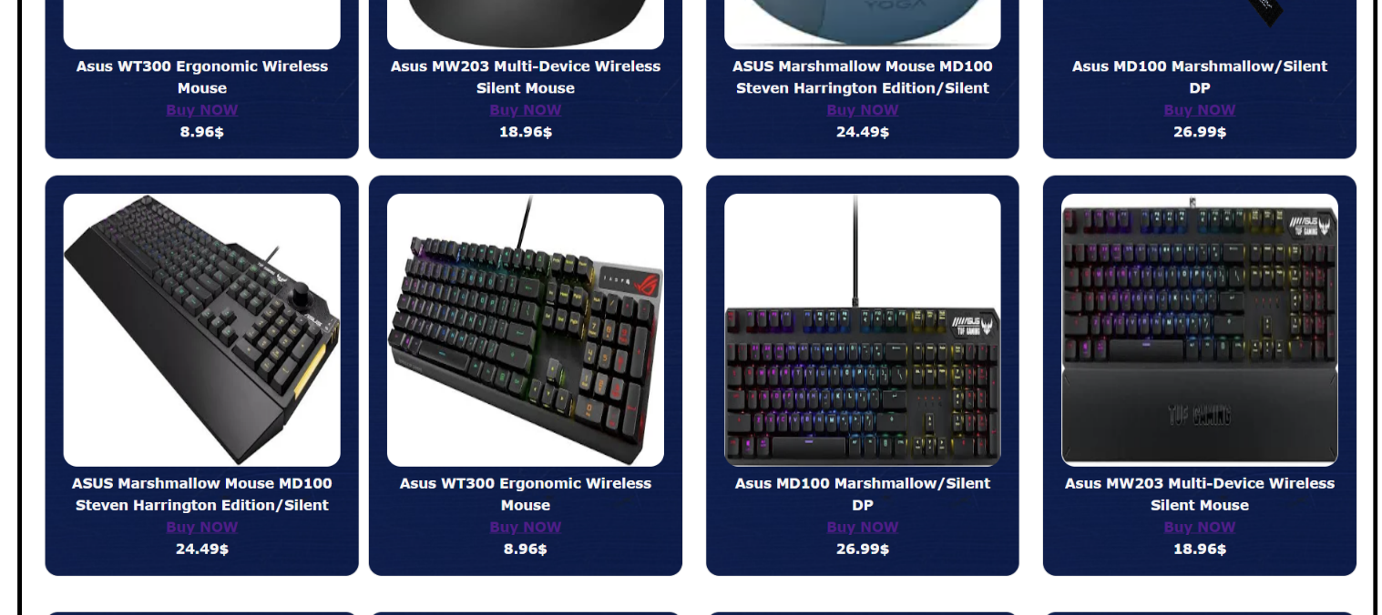

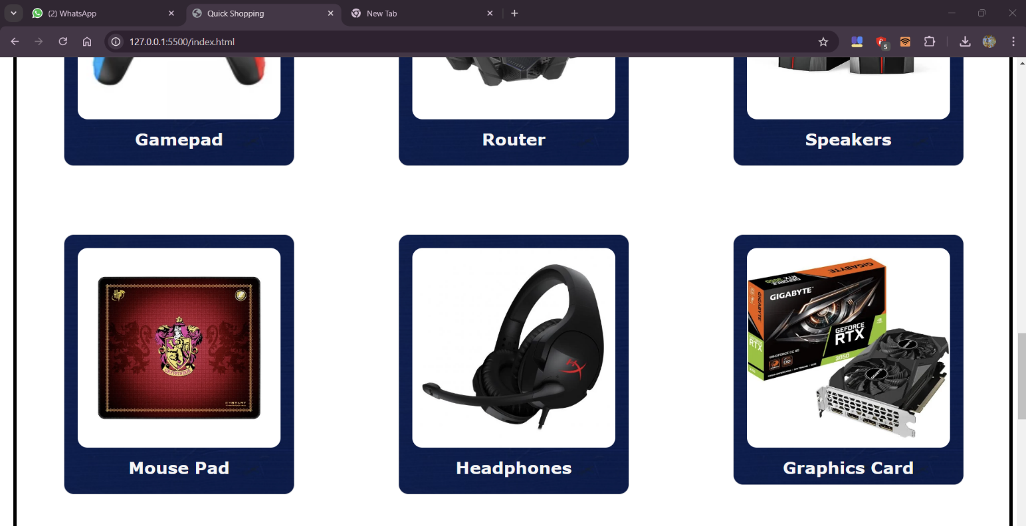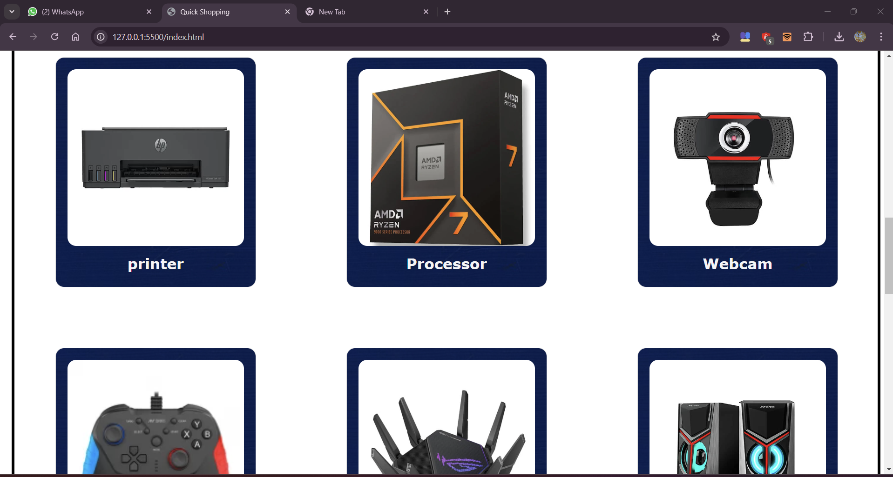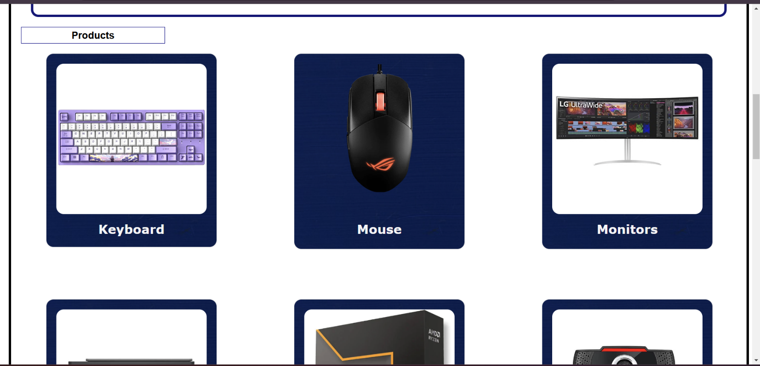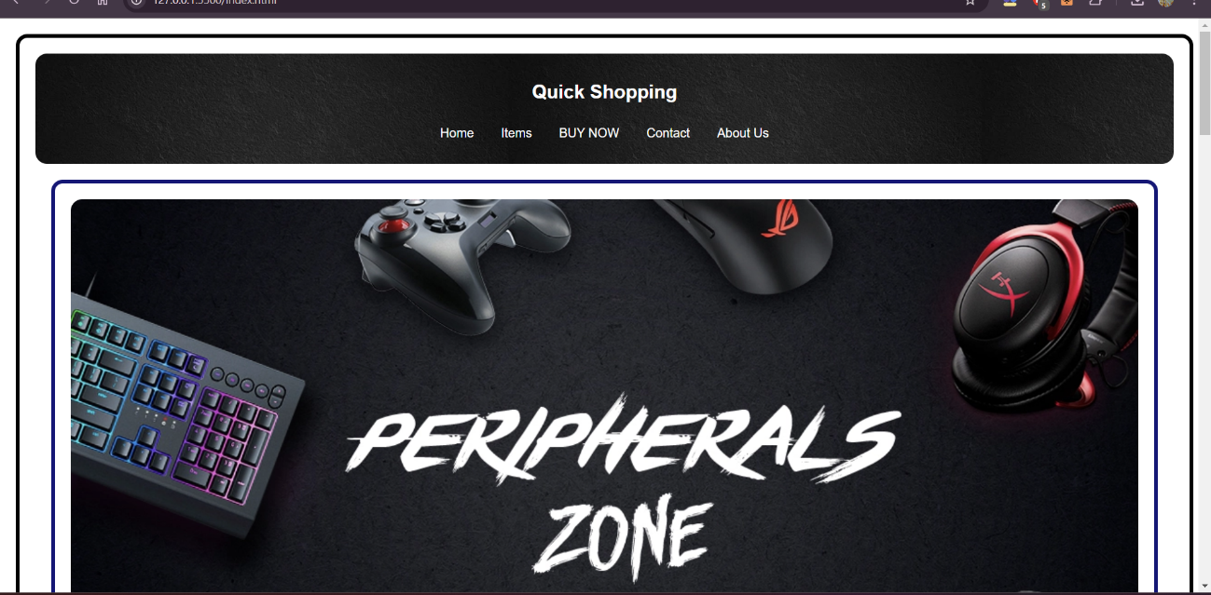

CONCLUSION

In conclusion, the quick shopping website project aimed to create a fast, user-friendly, and convenient online shopping platform for customers. Through this project, we successfully:

- Designed and developed a responsive and intuitive website interface

- Implemented a robust search and filtering system for easy product navigation

- Integrated a secure payment gateway for seamless transactions

- Developed features for quick checkout, order tracking, and personalized recommendations

The website offers a hassle-free shopping experience, allowing customers to quickly find and purchase products with minimal effort. With its fast loading speeds, mobile-friendliness, and intuitive design, this website provides an exceptional shopping experience for customers.

Future enhancements could include integrating AI-powered product suggestions, implementing a loyalty program, and expanding product categories to further improve the shopping experience. Overall, this project demonstrates the potential for quick shopping websites to revolutionize the way we shop online.

# REFERENCES

**W3 SCHOOLS:**

**"W3Schools is a popular online platform that provides web development tutorials and references for various web technologies. It serves as a comprehensive resource for individuals who are learning or looking to enhance their skills in HTML, CSS, JavaScript, and other related technologies.**

**The website offers a wide range of educational materials, including beginner-friendly tutorials, interactive examples, and hands-on exercises. These resources are designed to help users understand the fundamentals of web development and gain practical experience. Users can learn about topics such as web design, front-end development, back-end development, database management, and more.**